Department of Hispanic studies

The Cervantes theater
In Alcalá de Henares (1601-1971).
The Spanish Contribution to the Origins of
Modern European Playhouse Design
A presentation and talk by

Dr. John (Jay) Allen

February 16
5–6 pm

David Marksbury Theater
329 Rose St.

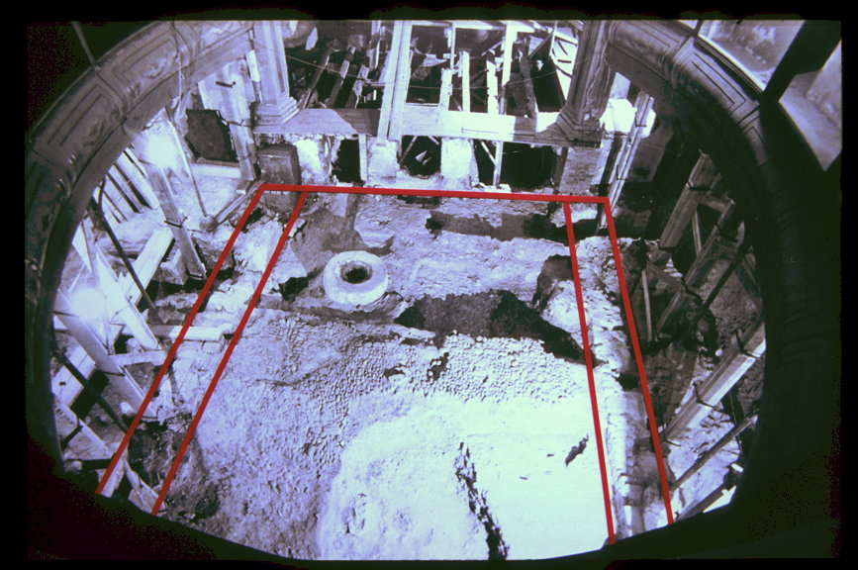
To give “to airy nothing, a local habitation and a name” (Shakespeare, A Midsummer Night’s Dream, Act V, ve “to airy nothing, a local habitation and a name” (Shakespeare, A Midsummer Night’s Dream, Act V, Scene 1)

